CS 561 Software Engineering

Fall 2017

Database Design Specification

Group Members：

Index

1. E-R Diagram 1

2. Tables 2

3. Dictionary 4

4. Connection Example 5

**Table 0.** Versions

|  |  |  |  |  |
| --- | --- | --- | --- | --- |
| NO. | Version | Date | Owner | Description |
| 1 | 0.1 | 09/30/2017 | Teng Li,Kang Li | First draft |
| 2 | 0.2 | 10/02/2017 | Teng Li, Kang Li | Add ta_name, ta_osu_id in t_question table, and the data of course_keywords in t_dictionary table |
| 3 | 1.0 | 10/03/2017 | Teng Li, Kang Li | 1. Create t_keywords table  2. Add last_name and first_name in t_user table  3. Add preferred_time, num_liked, stdnt_last_name stdnt_first_name, ta_last_name and ta_first_name in t_question table |
| 4 | 1.1 | 10/05/2017 | Teng Li, Kang Li | Add connection example code |
| 5 | 2.0 | 10/10/2017 | Teng Li | 1. Change osu_id to user_id in t_question and t_question_concern  2. osu_id could be NULL in the t_user |
| 6 | 2.1 | 10/13/2017 | Teng Li | 1. Change Data Type of osu_id to varchar in t_user |
| 7 | 2.2 | 10/24/2017 | Kang Li | 1. Change role definition in user table  2. Add role for each class student relationship |
| 8 | 2.2 | 2/12/2018 | Kang Li | 1. Add token for each user for adoption |

## E-R Diagram

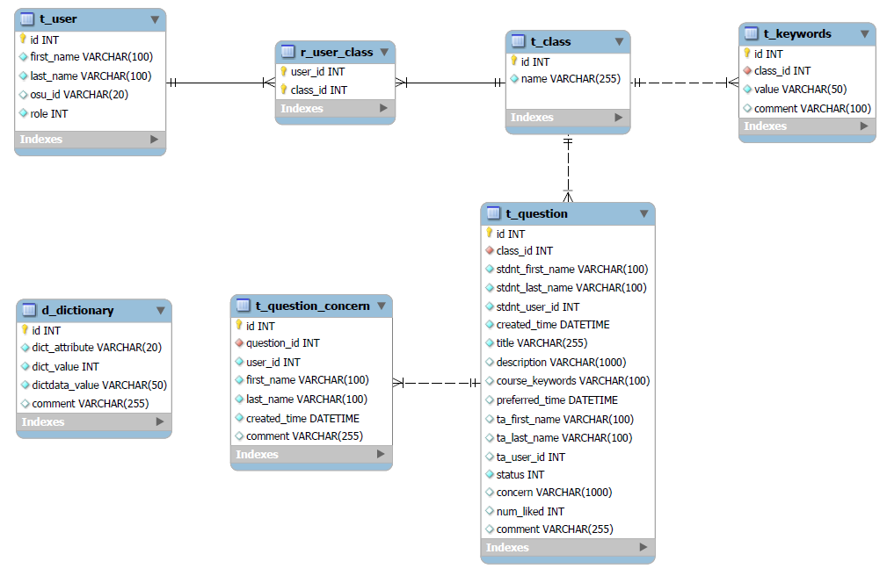

**Figure 1.1** E-R diagram

## Tables

**Table 2.1.** t_user

|  |  |  |  |  |
| --- | --- | --- | --- | --- |
| Column Name | Data Type | Not Null | Unique | Comments |
| id | INT(5) | Y | Y | PK |
| first_name | VARCHAR(100) | Y | N |  |
| last_name | VARCHAR(100) | Y | N |  |
| osu_id | VARCHAR(20) | N | Y |  |
| role | INT(2) | Y | N | 0 Student (default)  1 Admin |
| token | VARCHAR(50) | N | N |  |
| Token_time | Datetime | N | N |  |

**Table 2.2.** t_class

|  |  |  |  |
| --- | --- | --- | --- |
| Column Name | Data Type | Not Null | Comments |
| id | INT(5) | Y | PK |
| name | VARCHAR(255) | Y |  |

**Table 2.3.** r_user_class

|  |  |  |  |
| --- | --- | --- | --- |
| Column Name | Data Type | Not Null | Comments |
| user_id | INT(5) | Y | fk_r_user_class_to_t_user |
| class_id | INT(5) | Y | fk_r_user_class_to_t_class |
| role | INT(5) | Y | 0 Student (default)  1 TA |

Hints: primary key (user_id, class_id)

**Table 2.4.** t_question

|  |  |  |  |
| --- | --- | --- | --- |
| Column Name | Data Type | Not Null | Comments |
| id | INT(5) | Y | PK |
| class_id | INT(5) | Y | fk_t_question_to_t_class |
| stdnt_first_name | VARCHAR(100) | Y |  |
| stdnt_last_name | VARCHAR(100) | Y |  |
| stdnt_user_id | INT(10) | Y |  |
| created_time | Datetime | Y |  |
| title | VARCHAR(100) | Y |  |
| description | VARCHAR(100) | N |  |
| course_keywords | VARCHAR(100) | N | use “,” |
| preferred_time | Datetime | N |  |
| ta_first_name | VARCHAR(100) | N |  |
| ta_last_name | VARCHAR(100) | N |  |
| ta_user_id | INT(10) | N |  |
| status | INT(2) | Y | 0 proposed (default)  1 answered  2 deleted  3 signed |
| concern | VARCHAR(100) | N |  |
| num_liked | INT(3) | Y |  |
| comment | VARCHAR(100) | N |  |

**Table 2.5.** t_question_concern

|  |  |  |  |
| --- | --- | --- | --- |
| Column Name | Data Type | Not Null | Comments |
| id | INT(5) | Y | PK |
| question_id | INT(5) | Y | fk_t_question_concern_to_t_question |
| first_name | VARCHAR(100) | Y |  |
| last_name | VARCHAR(100) | Y |  |
| user_id | INT(10) | Y |  |
| created_time | Datetime | Y |  |
| comment | VARCHAR(100) | N |  |

**Table 2.6.** t_dictionary

|  |  |  |  |
| --- | --- | --- | --- |
| Column Name | Data Type | Not Null | Comments |
| id | INT(5) | Y | PK |
| dict_attribute | ARCHAR(20) | Y |  |
| dict_value | INT(2) | Y |  |
| dict_data | VARCHAR(50) | Y |  |
| comment | VARCHAR(100) | N |  |

**Table 2.7.** t_keywords

|  |  |  |  |
| --- | --- | --- | --- |
| Column Name | Data Type | Not Null | Comments |
| id | INT(5) | Y | PK |
| class_id | INT(5) | Y | fk_t_keywords_to_t_class |
| value | VARCHAR(50) | Y |  |
| comment | VARCHAR(100) | N |  |

## Dictionary

**Table 3.1.** Initialized data

|  |  |  |  |
| --- | --- | --- | --- |
| dict_attribute | dict_value | dict_data | comment |
| user_type | 0 | Student |  |
| user_type | 1 | TA |  |
| question_status | 0 | proposed |  |
| question_status | 1 | answered |  |
| question_status | 2 | deleted |  |
| question_status | 3 | signed |  |
|  |  |  |  |
|  |  |  |  |
|  |  |  |  |
|  |  |  |  |
|  |  |  |  |

## Connection Example

**Table 4.1. Connection** **information**

|  |  |
| --- | --- |
| Hostname | oniddb.cws.oregonstate.edu |
| Database Name | *~~%dbname%~~* |
| Username | *~~%username%~~* |
| Password | *~~%Password%~~* |

<?php

$dbhost = 'oniddb.cws.oregonstate.edu';

$dbname = *~~'%dbname%~~*';

$dbuser = '*~~%username%~~*';

$dbpass = '*~~%Password%~~*';

$mysql_handle = mysql_connect($dbhost, $dbuser, $dbpass)

or die("Error connecting to database server");

mysql_select_db($dbname, $mysql_handle)

or die("Error selecting database: $dbname");

echo 'Successfully connected to database!';

mysql_close($mysql_handle);

?>